Jose Lorenzo Miguel Aguilar Cohort 3 – Castro
Data Management and SQL March 28, 2020
Final Assignment

- What is a Data Moat? Why is it important to have one?
A Data Moat is when your company has a specific barrier to entry, the moat is something that makes your business unique and hard to compete with. It could be a brand, your unique data that no other company can or are currently collecting that brings value to the company. These moats are to ensure your position in the industry.
- What is the difference between OLAP and OLTP Databases? Why would you choose one over the other?
The OLTP is transactional based, while the OLAP is an analytical based system. The decision on which to use is determined by the companies’ business model. If the company deals with few customers (B2B setting) they should use OLAP in order to analyze the data, more. In a situation where you have lots of customers all at once (B2C) I would suggest OLTP instead as it’s simpler queries would be better utilized with the massive amounts of data present in your database.
- What are the 3 different roles in a modern data team? Which problems do each of them solve? How do they compare with each other?
An organized data centered team comprises of three important roles:
A Data Analyst, Engineer, and Scientist.
The Data Analyst focuses on answering business questions. They are the connection between business and data, He understands both and converts the data into insights.
The Data Engineer is responsible for the accessibility of the data, they ensure that the data is being stored, secured, and is accessible to the right people in the company.
Lastly, the Data Scientist builds predictive models and automated classifications based on the data provided to aid the company in making better business decisions

- Share your opinion on current data privacy laws. Are they doing enough to protect consumers? Why or why not?
Based on our exercise of getting our data from Facebook, I believe that data privacy laws still can be massively improved. Each of us merely use the internet for personal and business reasons, but more often than naught we are unknowingly being recorded in some way. The fact that there are some situations where we are unaware of the fact that a company gathers our information is a great cause for concern given that an individual’s life is online based.
- How would you define the relationship between car owners and cars in the Entity Relationship (ER) model? Please provide an explanation why using real world examples.
In an Entity Relationship (ER) model, we visualize the relationships between users and the respective gadget. The relationship between car owners to their cars are typically 1:m due to only one person in the household being able to own several cars. Although it may be used by many in a household, it is still owned (legally) under one specific name.

Part 2:
- You are asked to model the many to many relationships between students and classes in a relational database.
  - What changes do you need to make to support this relationship?
  - Please create an ER diagram to show how these entities will relate to each after your changes.
STUDENTS M:M CLASSES

I added several channels in between students till the class. These channels show the necessary steps required to accurately place a student in their proper classes. Each student corresponds to one enrollment each, which can select from various programs in their chosen campus, which contains the various classes they take in order to complete their program.
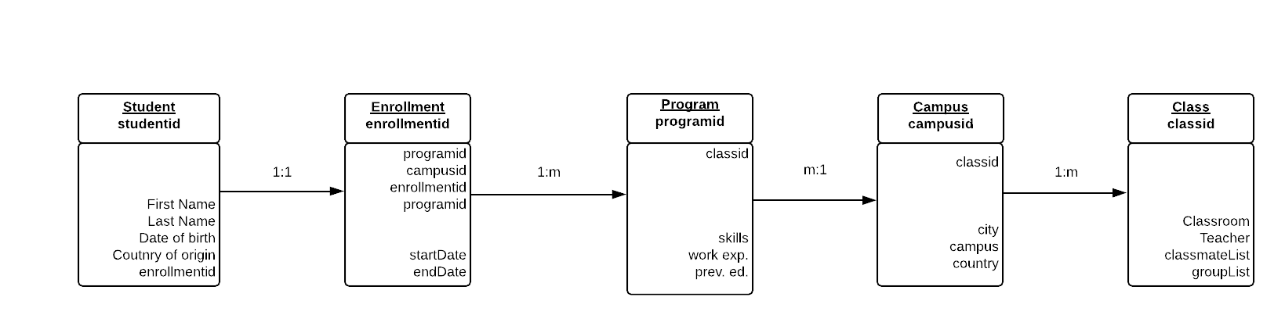

- You are asked to model the many to many relationships between customers and products in a relational database.
  - What changes do you need to make to support this relationship?
  - Please create an ER diagram to show how these entities will relate to each after your changes.
CUSTOMERS M:M PRODUCTS

Much like the first one, I added the necessary steps that are needed when someone buys something online. But it the system loops when there is repeated purchase. Otherwise discard the last stage.
Many customers go to one store which receives many orders each containing several products all going to their individual customers.
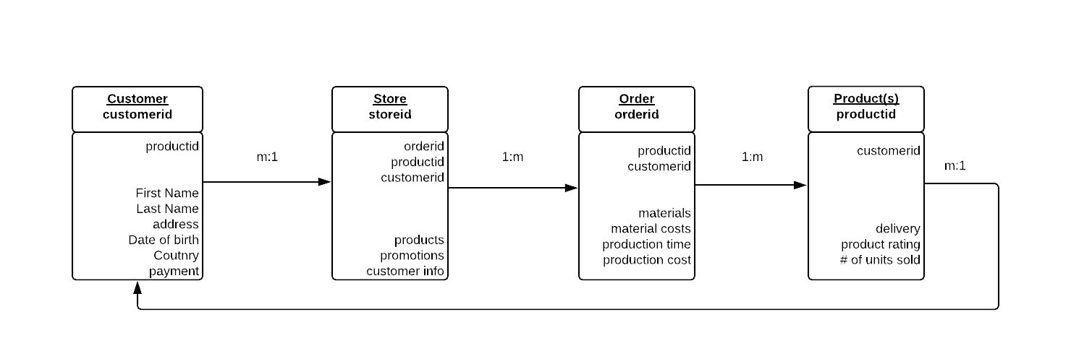

- Design an ER diagram for a library reservation system for a family of libraries based on the given characteristics.
  - This system is for multiple libraries
  - This system is for multiple borrowers
  - There are multiple types of content that can be borrowed
  - Borrowers can borrow multiple items at the same time
  - Borrowers can borrow multiple types of content
Given the unique fact that there are no limits to what a borrower can borrow from a library, there are multipls many to many relationships. But each individual book can only borrowed by one person at a time, so this relationship (the borrower and the book) is the only multiple to one relationship. As they may borrow a lot, but the book cannot be shared by many borrowers at the same time
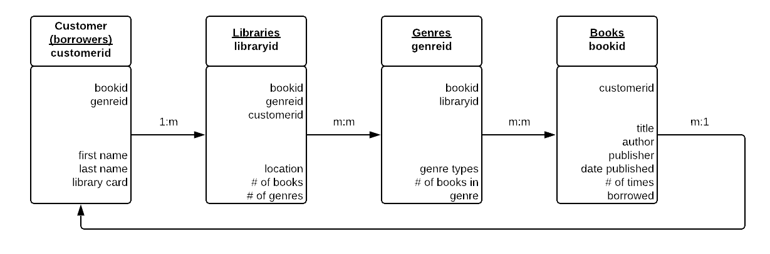
Essay:
There are 34 instances where the station is left with no bikes for other users.
This is a large problem as this means that customers use these bikes one way. These customers do not use the bike to their destination and then come back to these stations. Without bikes being available, we lose possible profit, as these individuals would need to use another service aside from the bike share.
The top 5 most popular borrowing stations in the network are:
- Belgrove Street, king’s Cross with 234,458 usages
- Hyde Park Corner, Hyde Park with 215,629 usages
- Waterloo Station 3, Waterloo with 201630 usages
- Black Lion Gate, Kensington Gardens with 161952 usages
- Albert Gate, Hyde Park with 155,647 usages
These are understandable as these are hotbeds for tourism. Hyde park and kings cross are heavily populated areas all day long.
While the top 5 end destination stations are:
- Belgrove Street, Kings Cross with 231,802
- Hyde Park Corner, Hyde Park with 215038
- Waterloo Station 3, Waterloo with 193200
- Albert Gate. Hyde Park with 157964
- Hop Exchange, The Borough with 156,964
Given all of these, we can say that the stations that are empty are heavily populated with people. The stations near Hyde park are due to tourists and locals as this is the largest park in London, UK (and the most well-known).
People use stations going to king’s cross and Hyde Park. But they do not use the bike service going back, this may be due to exhaustion or stress… they possibly take a cab, or an uber going back to their respective homes after a day of sightseeing.
A possible solution to this problem is to incentivize customers to bring back the bikes to their original locations through discounts, or promotions. This allows users to be more inclined in returning the bikes to their original stations. You may possibly have two different promotions wherein if the bike is returned to the original station, the overall price would be discounted by 20%, while if returned close by instead, the discount would be given at a lesser rate.

Part 4:
In this section, you’re going to build an operational dashboard, using Google Data Studio (Links to an external site.), to track the health of your bike system. Use the same data set as in section 3. You will paste a screenshot of your response in your assignment submission and share your report with so we can take a direct look at it.
Build an operational dashboard to answer the following business questions:
Station Health
- How many stations are at capacity, empty, or out of service?
- What is the fill rate (bikes available/capacity) for each station?
- What is the most popular station to start rides for all time?
- What is the most popular station to end rides for all time?
- What are the top 3 most popular trips (start and end station combination) for all time?
- Which hours of the day does usage peak on weekdays?
- Which hours of day does usage peak on weekends?
System Health
- How many trips are there per day?
- What is the average trip duration?
- What was the shortest trip?
- What was the longest trip?
- How many total hours of usage does each bike have?
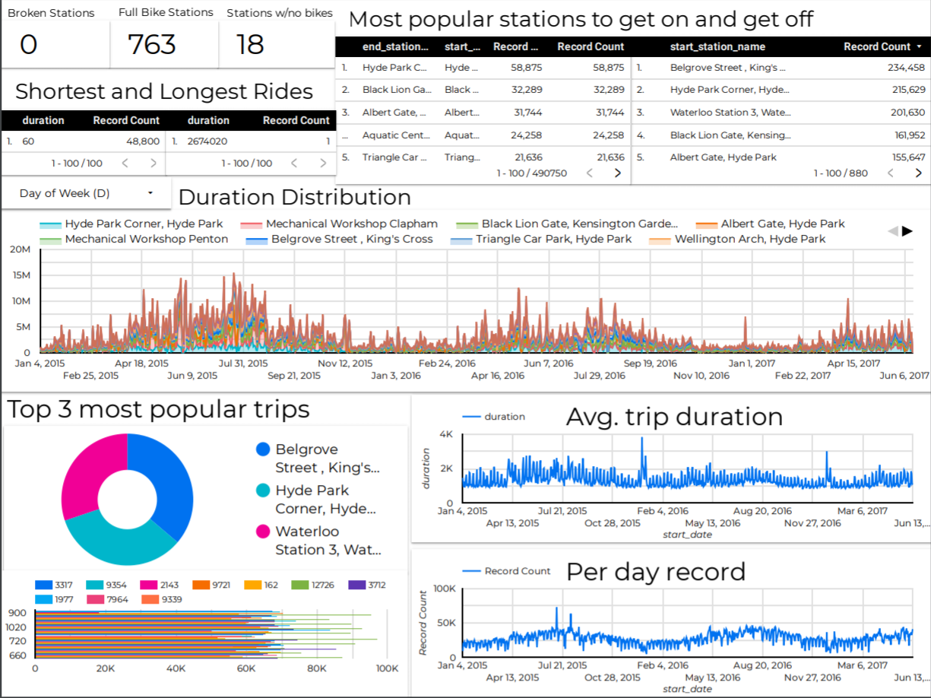
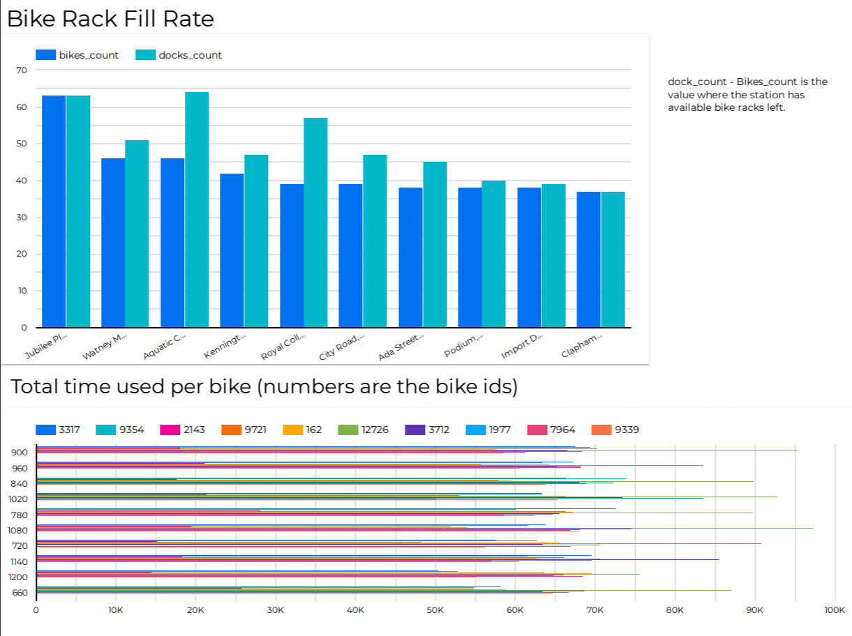

Appendix:
Part 3:
Query for 1st question:
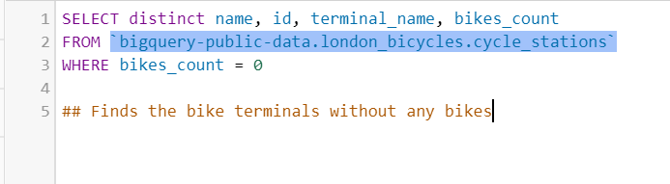

Output:
(9 out of 9 results)
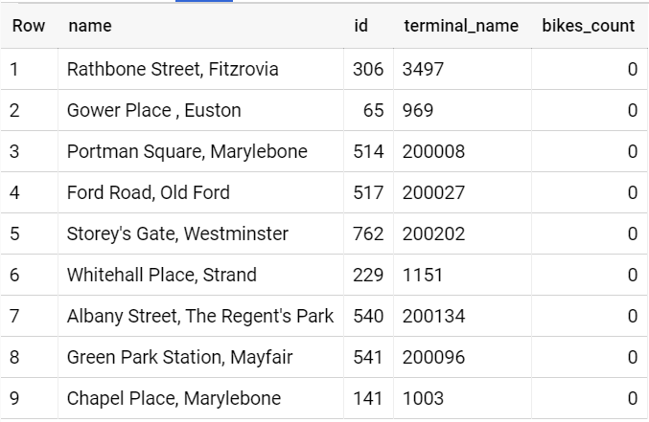

Query for 2nd question:
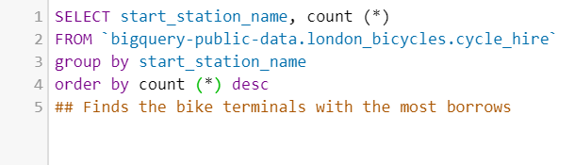
Output:
(12 out of 880 results)
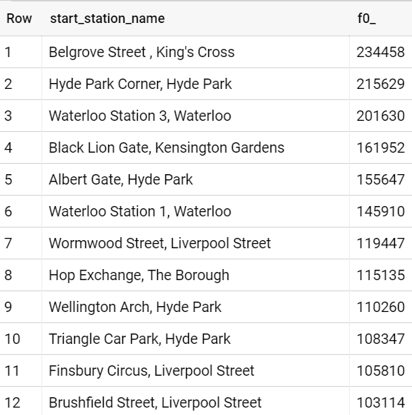

Query for 3rd Question:
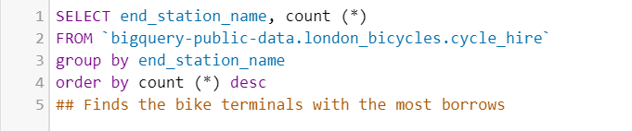
Output:
(12 out of 882 results)
